

**An Exploratory Analysis of the City of Los Angeles Call Center Data**

**DSO545 – Fall 2016**

**Data Visualization Project**

**Adeesh Goel**

**Bharadwaj Kachapuram**

**Hassaan Khalid**

**Nate Cohn**

**Paige Schwimer**

**Saavi Gupta**

B. Table of Contents

|  |  |
| --- | --- |
| P.3 | A. Executive Summary |
| p.4 | C. Introduction |
| P.5 | D. Service Requests by Department |
| P.8 | E. Service Requests by Request-Type |
| P.11 | F. Service Requests by Channel (Phone, app, other) |
| P.13 | G. Service Requests by Call Resolution |
| P.16 | H. Trends in Volume of Service Requests |

**A. Executive Summary**

After exploring the City of LA call-center data, we observed various trends outlined in the report below. The following are the key recommendations we arrived at based on our supporting analysis discussed in the report:

* Improve the call center operation efficiency by employing interactive voice recognition to a greater extent in order to reduce agent workload and also allow for specialization of agents for particular problems. We also recommend employing the services of Afiniti (a McKinsey Solution) to streamline the call center through intelligent agent caller routing.
* There is room for improvement when it comes to response times for app requests. Requests made on phone are met earlier. Proper training, and KPI and performance management is advised to bring the teams dealing with app requests up to par with the other teams.
* The app is being underutilized and has great potential for expansion. Marketing campaigns are suggested aiming at campaigns such as controlling water wastage.
* It is advised to use the experience of the city of Vancouver whereby graffiti was legalized in certain areas to deter the act from taking place all over the city. There is only one wall near Venice Canal where graffiti is legal in LA; more such locations may deter individuals from carrying out the act in residential, or otherwise off limit, areas.

**C. Introduction**

When analyzing the 311 call-center tracking data for the city of Los Angeles, we focused our exploratory analysis on four primary areas.

* Service Requests by Department: In this section, we assessed the volume of requests received by the various departments, and also considered variation by police precinct, zip codes and other location aggregations.

* Service Requests by Request-Type: In this section, we analyzed the distribution of request percentages by the various service types (e.g. Bulky Items, Graffiti Removal, etc.), and considered the changes in these percentages over time.
* Service Requests by Channel: In this section, we explored the differences in the volume and percentages of request types by the request source (phone, app, other) and considered the changes in usage over the past several years. We also considered hourly and weekly variations in app vs phone requests.
* Service Requests by Call Resolution: We evaluated the performance of the department by two important measures, call resolution percentage and service efficiency (response times). For the call resolution percentages, we explored differences across departments, request types, and looked at the time trend in the same. For service efficiency, we focused on the turnaround time differences for phone vs app requests.

In each section we have presented the key insights, and formulated potential action takeaways based on these insights.

**D. Requests by Department**

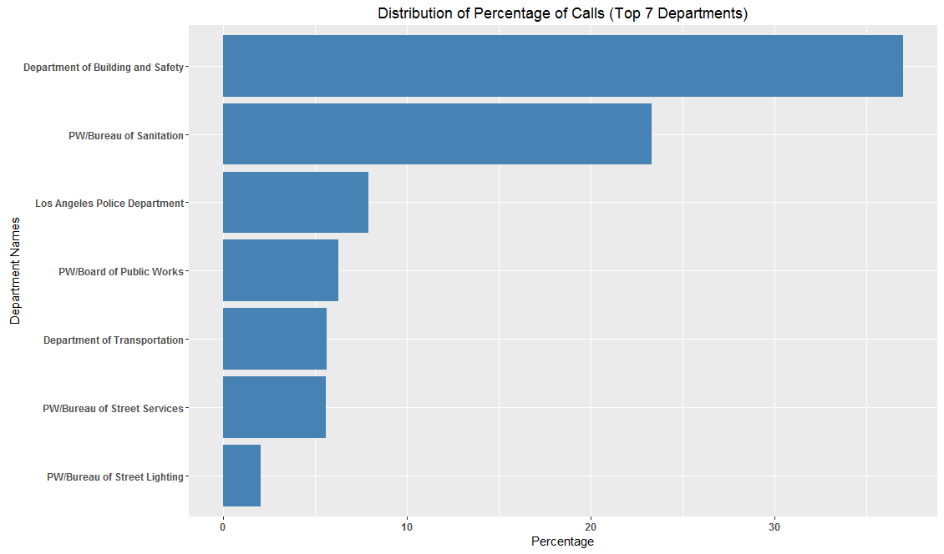

Insight: More than 80% of all requests are from the 7 categories shown with Building and Safety, and Sanitation generating highest call volume with 60% calls.

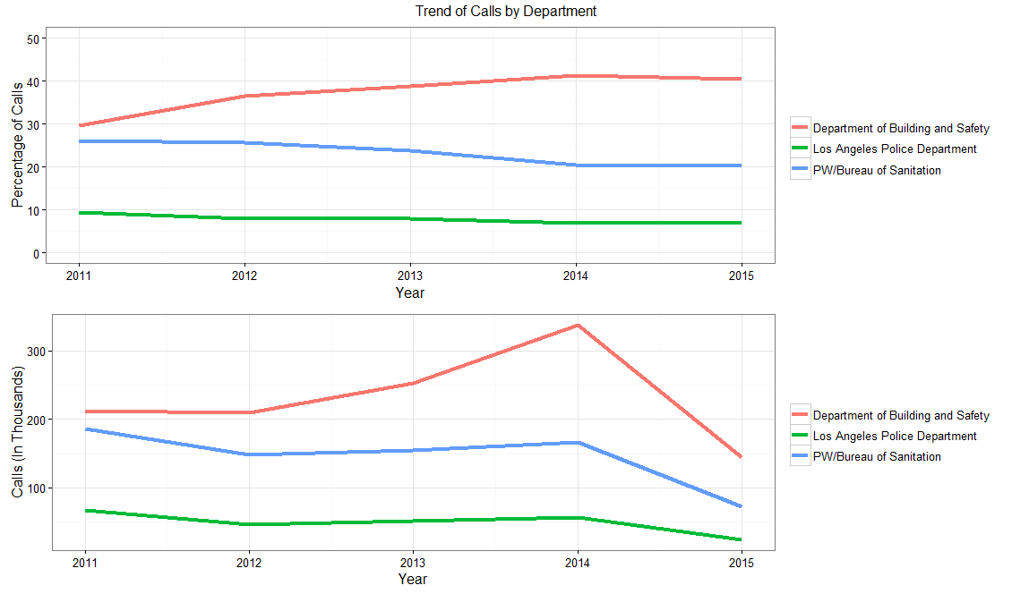

*(Note: For 2015 the data does not include all months)*

Insight: We see that number of calls has remained relatively constant for LAPD while it has increased quite significantly for Building and Safety.

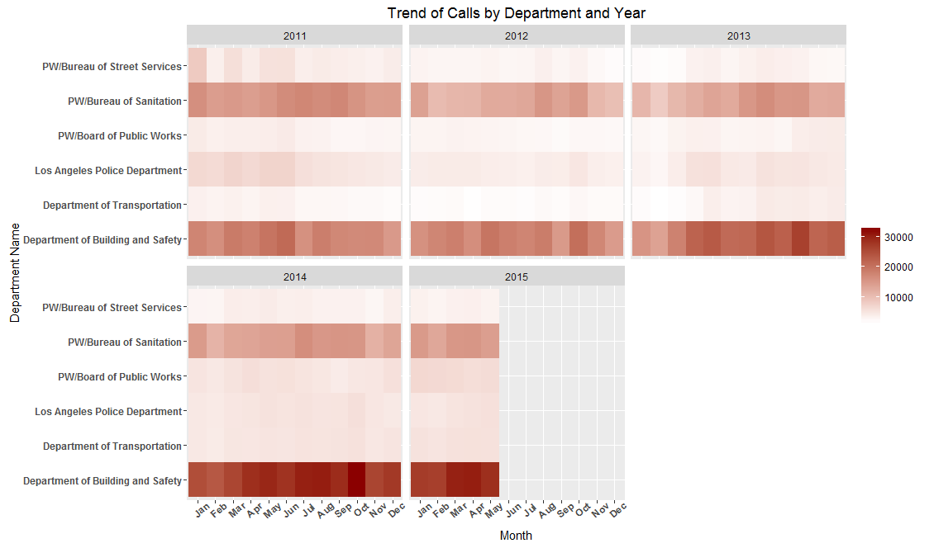

Insight: Additionally, we notice here that the number of service requests for the Sanitation (and the Street Services Bureau) has seen a decline over the past few years.

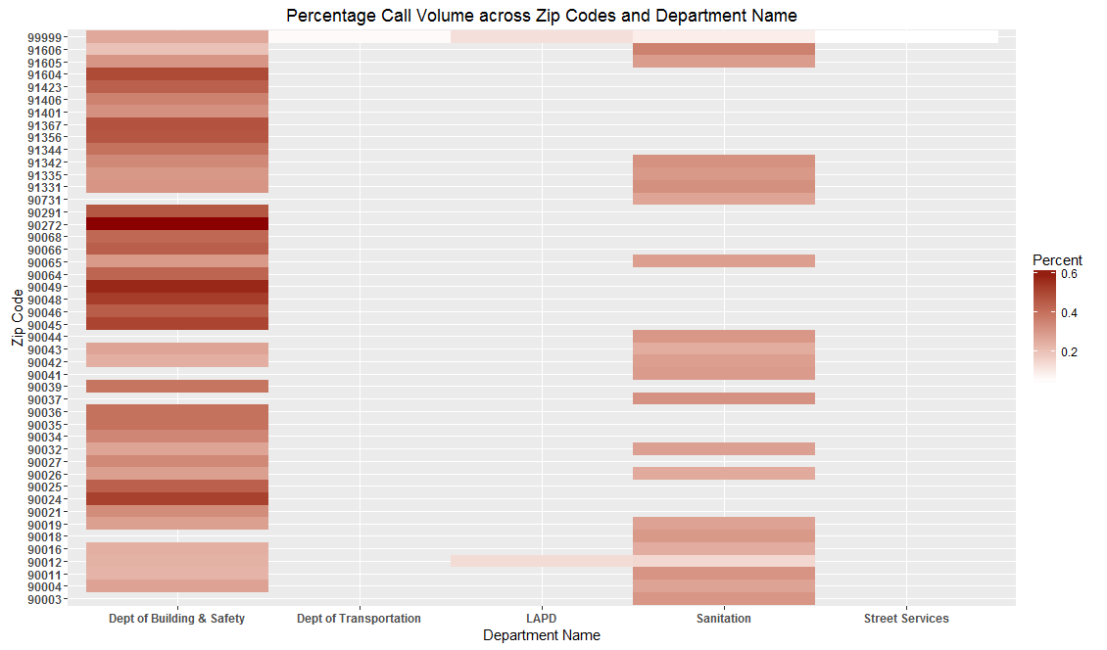

Insight: Above we noticed that zips 90272 (Pacific Palisades), 90049 (Brentwood) and 90024 (near UCLA) had an exceedingly high request count for the Building and Safety department.

Key Action Takeaway

1) Optimize the Interactive-Voice-Response, such that calls are appropriately filtered and routed based on the request type. It is evident the Building and Safety, and Sanitation departments need significantly higher support for requests.

2) Staffing and training decisions may be made considering the above trends. We can ensure that the identified zip codes have adequate personnel to tackle issues.

**E. Requests by Request-Type**

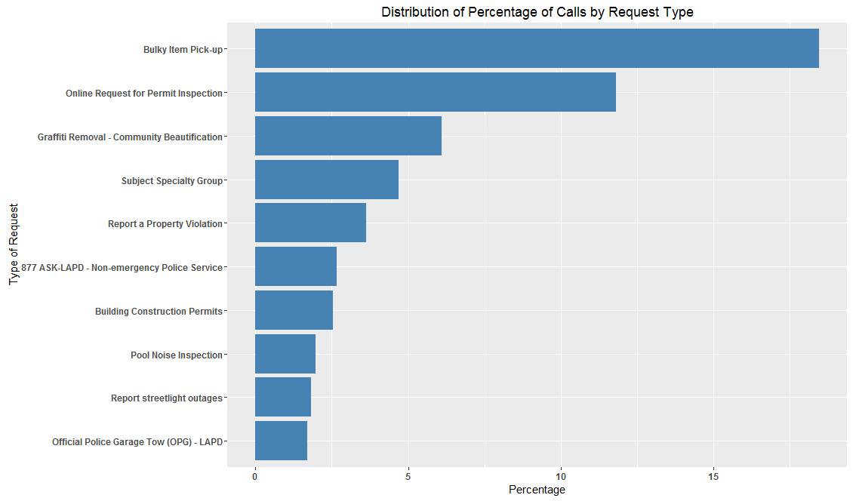

Insight: Most of the requests are coming for bulky item pick-up, online request for permit inspection and graffiti removal.

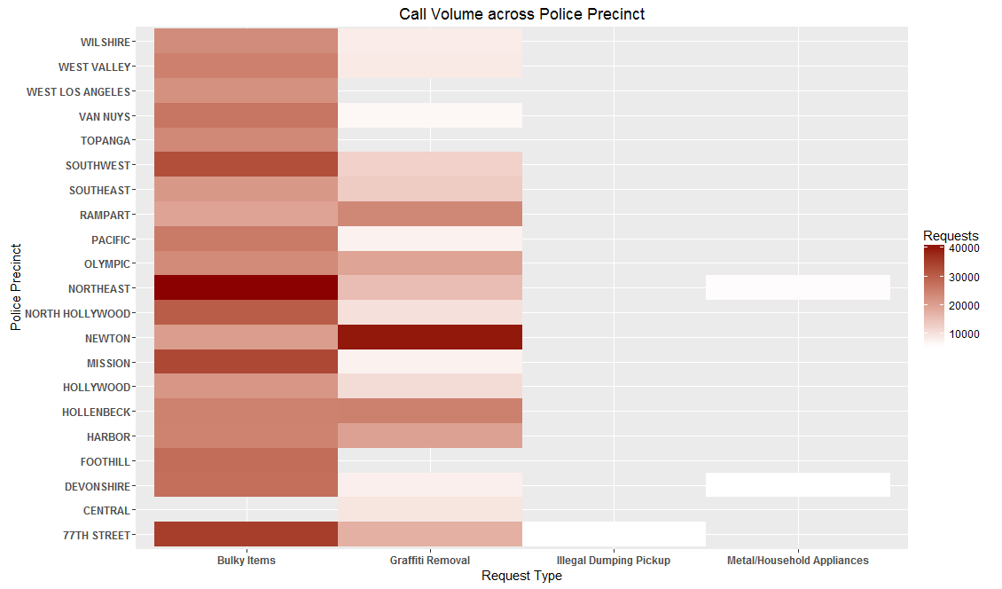

Insight: We notice that the Northeast precinct, the Mission precinct and the 77th Street precinct are noticing the highest request volume for bulky item removals. Additionally, the Newton precinct has an exceedingly high call volume for the graffiti removal requests.

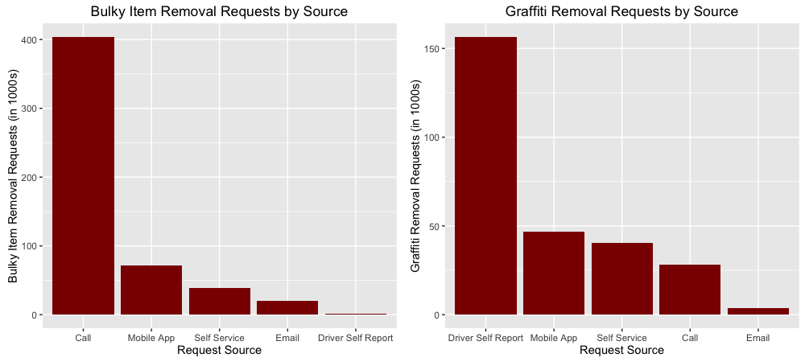

Insight: The most common request source for bulky item removals is “Call” whereas the most common source for graffiti removals is the “Driver Self Report”.

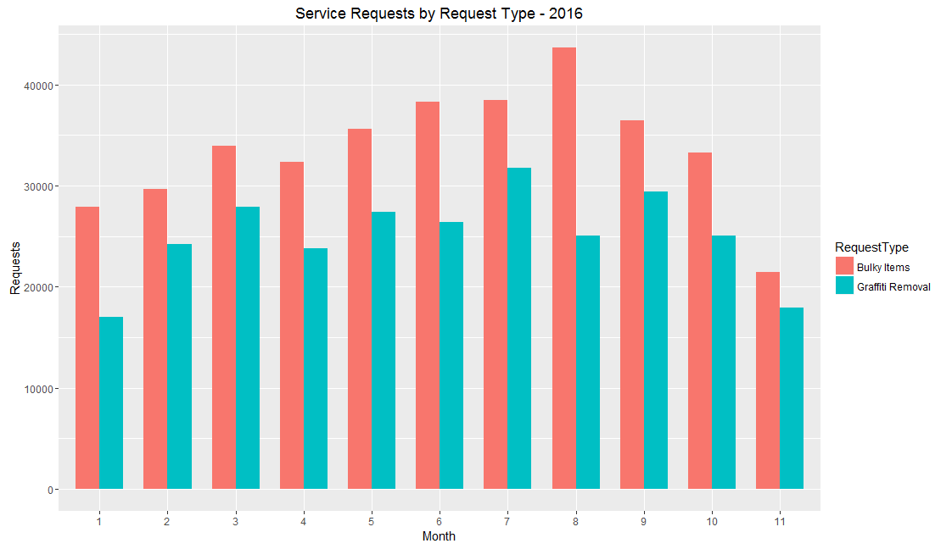

Insight: In the above chart we see that there is a noticeable peak in bulky item removal requests in the month of August. This is likely due to the move-in / move-out for back-to-the-school season for most college student populations in Los Angeles.

Key Action Takeaways

1) Optimize preparation for bulky item removal during college move-in. It is noticeable that certain months have higher requests for the bulky item removal. Anticipating such a surge in requests during months can help the manage the sudden flood of requests.

2) Staffing and training decisions may be made considering the above trends. We can ensure that the identified high volume police precincts for bulky item and graffiti removal requests are staffed and trained appropriately.

**F. Requests by Channel**

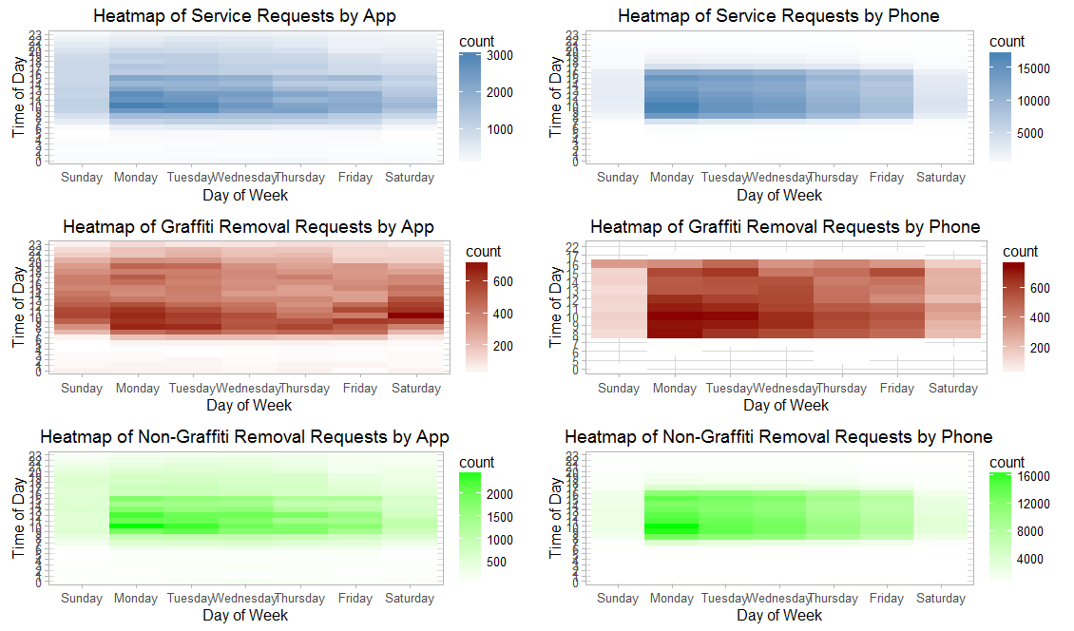

Insight: In general, we notice that more number of requests are made during the beginning of the week. Also, we notice that the requests by app are more spread out over the duration of the week than the requests by phone. Finally, we see that at 8am (opening time) and 4 – 5pm (closing time) notice a spike in requests each day (especially early in the week)

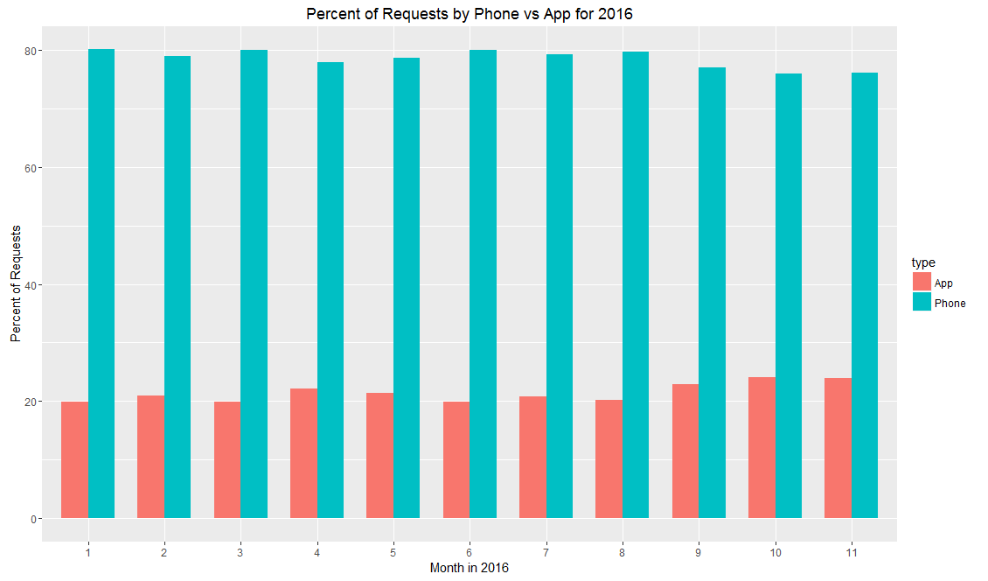

Insight: We notice that although the overall trend is relatively constant, about a 5% increase in the app usage (and a 5% decrease in phone usage) is seen across 2016.

Key Action Takeaways

1. Promote the app usage to ensure more even and manageable spread of requests across the week.
2. Ensure that staff is well prepared to handle the surge in volume for the hours just after the opening and just before the close of the day.

**G. Requests by Call Resolution**

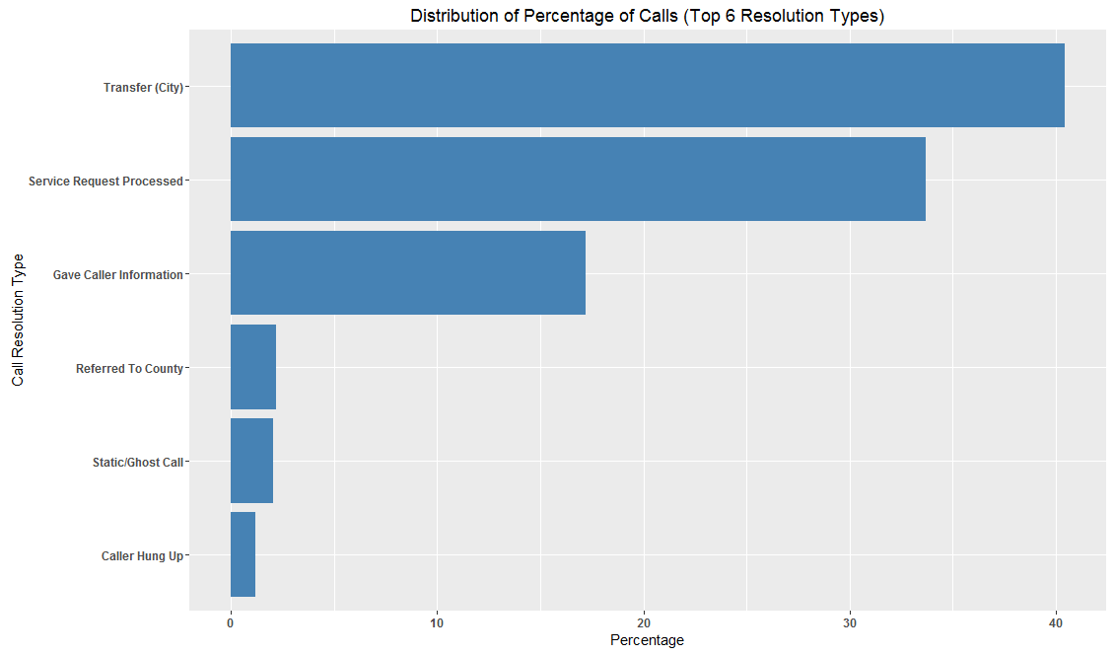

Insight: The highest percentage of calls are transferred and service requests processed/gave caller information are the next highest resolution types.

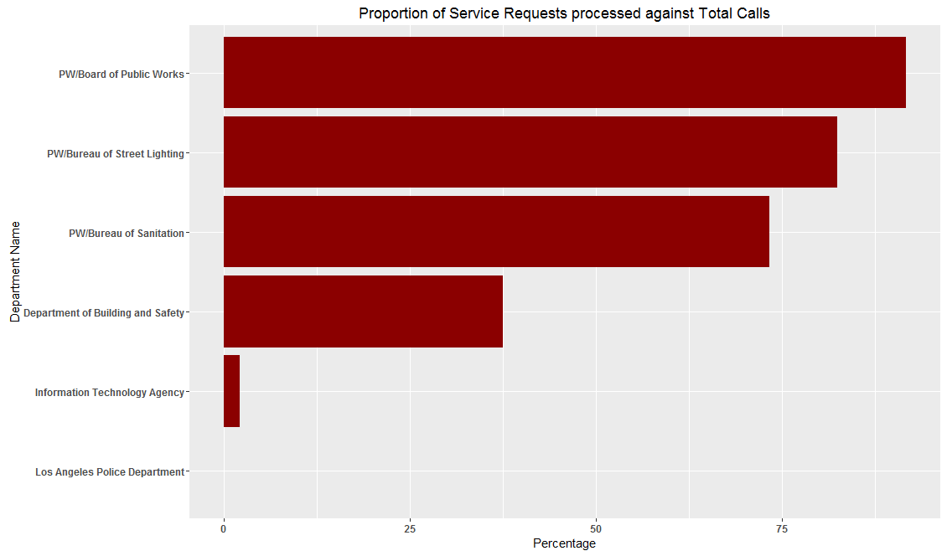

Insight: We notice that the public works department has a high call resolution percentage (about 82%) whereas the sanitation and building and safety departments have considerably lower requests processed percentages (30 - 70%)

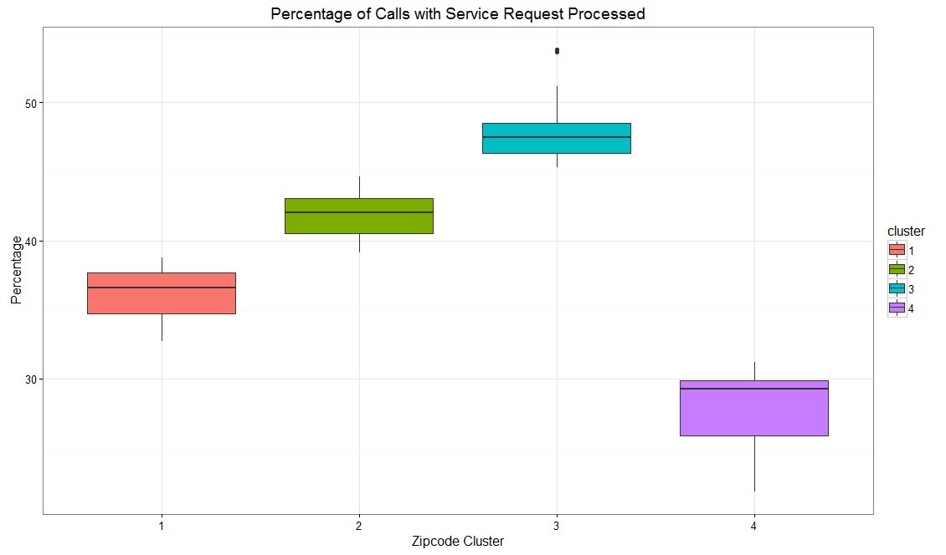

Insight: We noticed that based on call resolution percentage four identifiable zip code clusters can be created.

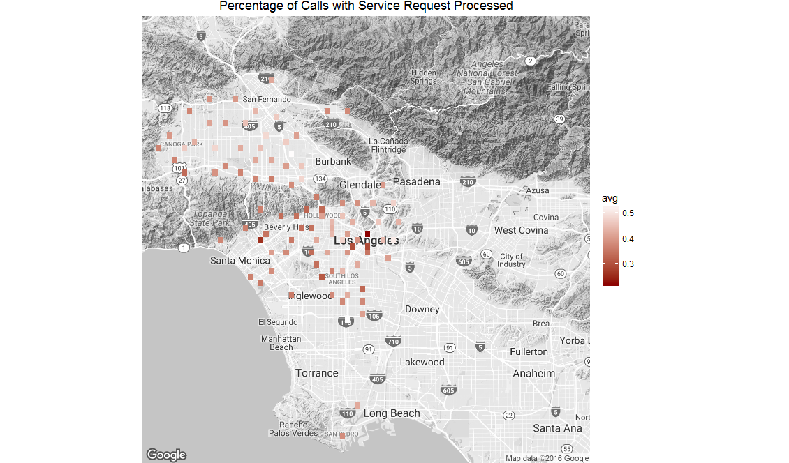

Insight: The resolution percentage is highly correlated to the proximity to center of city with the downtown areas noticing better call resolution percentages.

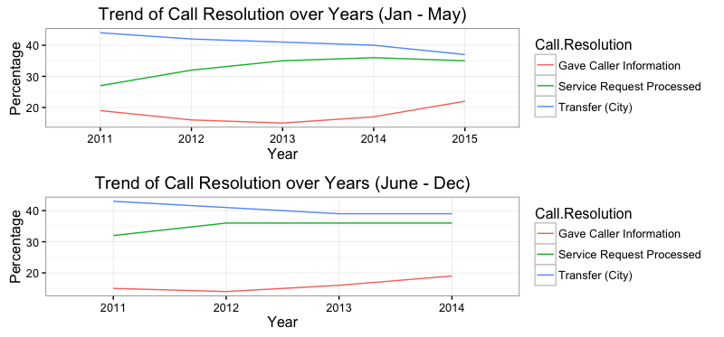

Insight: We noticed that overall transfer of call percentage has decreased whereas the other resolution types have increased percentages.

Key Action Takeaways:

1. IVR needs to be optimized as very high number of resolution types are transfer as well as provide information. For instance, we may have specific staff trained for information-providing requests.
2. Action steps need to be taken to bring call resolution for building and safety department up and investigating the reasons for a low resolution percent may be important. Additionally, we must ensure that zip code clusters with low resolution percentages are adequately addressed.

**H. Trends in Volume of Service Requests**

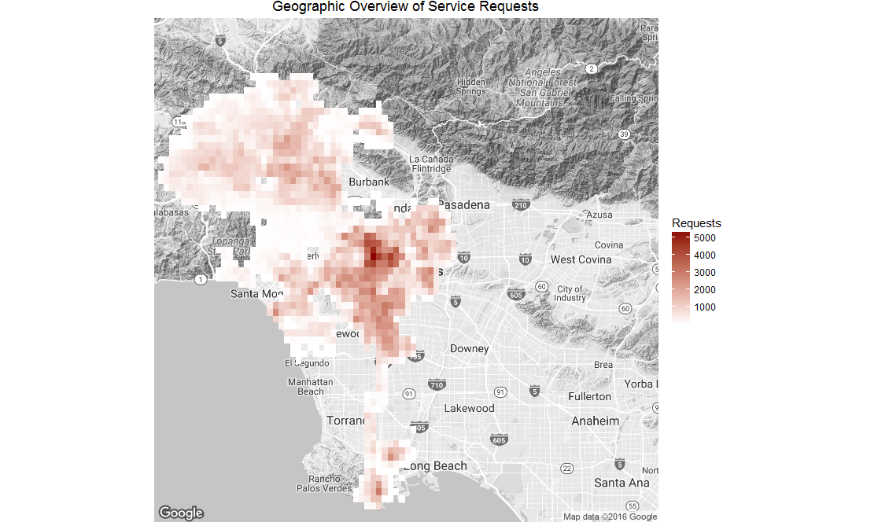

Insights: Higher volume of requests are seen from the areas closer to downtown/center of the city. It is commendable that service resolution is still higher in these areas.

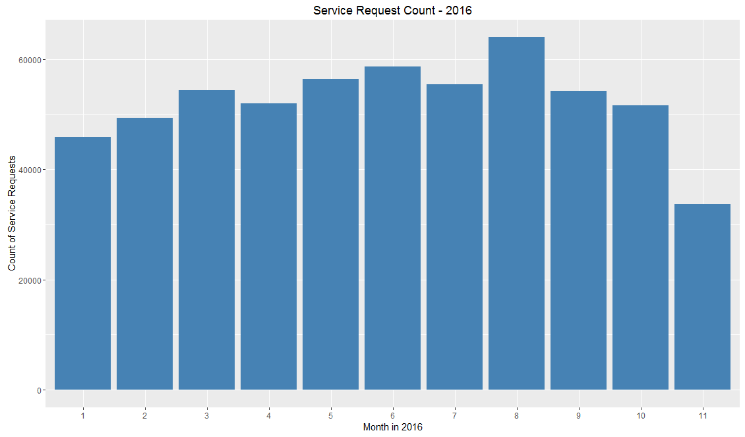

Insights: We notice that in general summer months see a higher number of service requests.